- Text-to-SQL Workflow
Build an end-to-end LLM workflow with retrieval and query generation
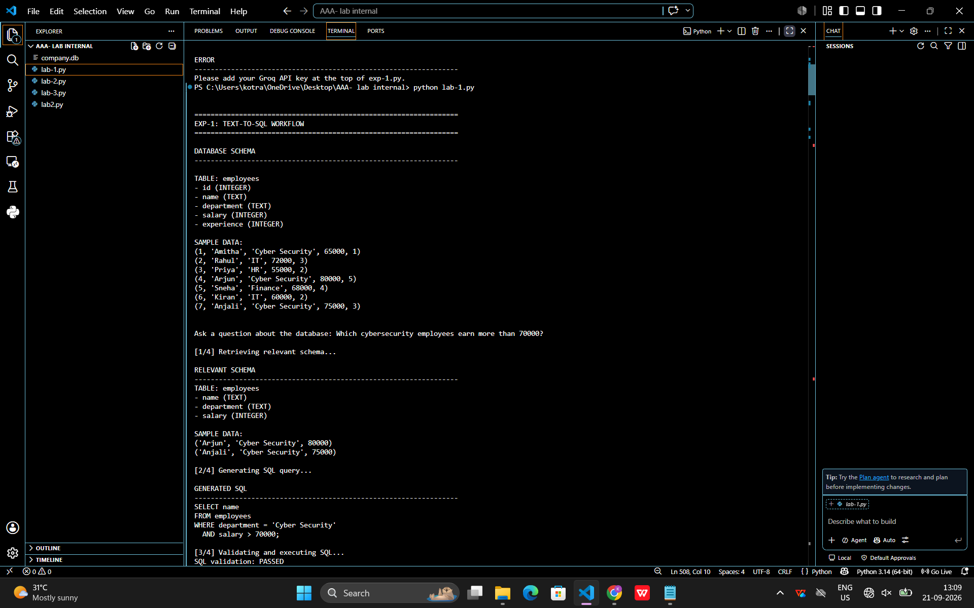

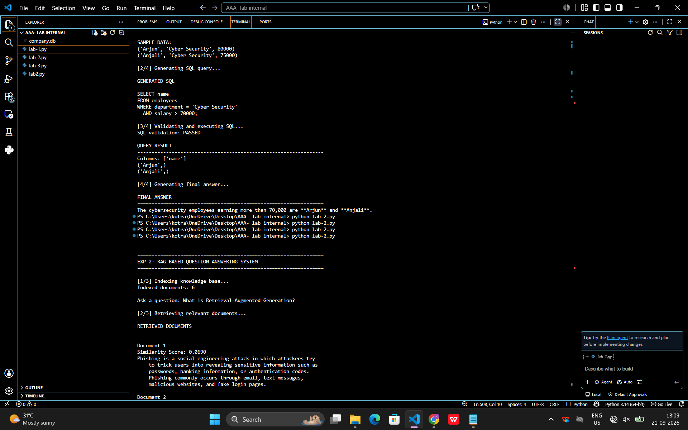
# ============================================================
# EXP-1: TEXT-TO-SQL WORKFLOW
# Build an end-to-end LLM workflow with retrieval
# and query generation
# ============================================================

import sqlite3
from groq import Groq

# ============================================================
# 1. GROQ CONFIGURATION
# ============================================================

# Put your Groq API key here
GROQ_API_KEY = "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"

MODEL = "openai/gpt-oss-120b"

client = Groq(api_key=GROQ_API_KEY)

# ============================================================
# 2. CREATE SAMPLE DATABASE
# ============================================================

def create_database():

conn = sqlite3.connect("company.db")

cursor = conn.cursor()

cursor.execute("""
CREATE TABLE IF NOT EXISTS employees (
id INTEGER PRIMARY KEY,
name TEXT,
department TEXT,
salary INTEGER,
experience INTEGER
)
""")

# Check whether data already exists
cursor.execute("""
SELECT COUNT(*)
FROM employees
""")

count = cursor.fetchone()[0]

# Insert sample data only if table is empty
if count == 0:

employees = [
(1, "Amitha", "Cyber Security", 65000, 1),
(2, "Rahul", "IT", 72000, 3),
(3, "Priya", "HR", 55000, 2),
(4, "Arjun", "Cyber Security", 80000, 5),
(5, "Sneha", "Finance", 68000, 4),
(6, "Kiran", "IT", 60000, 2),
(7, "Anjali", "Cyber Security", 75000, 3)
]

cursor.executemany("""
INSERT INTO employees
VALUES (?, ?, ?, ?, ?)
""", employees)

conn.commit()

return conn

# ============================================================
# 3. GET DATABASE SCHEMA
# ============================================================

def get_database_schema(conn):

cursor = conn.cursor()

cursor.execute("""
SELECT name
FROM sqlite_master
WHERE type='table'
AND name NOT LIKE 'sqlite_%'
""")

tables = cursor.fetchall()

schema = ""

for table in tables:

table_name = table[0]

schema += f"\nTABLE: {table_name}\n"

# Get columns
cursor.execute(
f"PRAGMA table_info({table_name})"
)

columns = cursor.fetchall()

for column in columns:

column_name = column[1]
column_type = column[2]

schema += (
f"- {column_name} "
f"({column_type})\n"
)

# Get sample records
cursor.execute(
f"SELECT * FROM {table_name} LIMIT 10"
)

rows = cursor.fetchall()

if rows:

schema += "\nSAMPLE DATA:\n"

for row in rows:

schema += f"{row}\n"

return schema

# ============================================================
# 4. GROQ FUNCTION
# ============================================================

def ask_groq(prompt, temperature=0):

try:

response = client.chat.completions.create(
model=MODEL,
messages=[
{
"role": "user",
"content": prompt
}
],
temperature=temperature
)

return response.choices[0].message.content.strip()

except Exception as e:

print("\nGroq API Error:")
print(e)

return None

# ============================================================
# 5. CLEAN GENERATED SQL
# ============================================================

def clean_sql(sql):

if not sql:
return ""

# Remove markdown code blocks
sql = sql.replace("```sql", "")
sql = sql.replace("```", "")

sql = sql.strip()

# Remove "SQL:" if model adds it
if sql.lower().startswith("sql:"):

sql = sql[4:].strip()

return sql

# ============================================================
# 6. SQL SECURITY VALIDATION
# ============================================================

def validate_sql(sql):

if not sql:
return False

upper_sql = sql.upper().strip()

# Only SELECT / WITH queries are allowed
if not (
upper_sql.startswith("SELECT")
or upper_sql.startswith("WITH")
):
return False

dangerous_keywords = [
"DROP ",
"DELETE ",
"UPDATE ",
"INSERT ",
"ALTER ",
"TRUNCATE ",
"CREATE ",
"REPLACE "
]

for keyword in dangerous_keywords:

if keyword in upper_sql:

return False

return True

# ============================================================
# 7. MAIN TEXT-TO-SQL WORKFLOW
# ============================================================

def text_to_sql():

print("\n")
print("=" * 65)
print("EXP-1: TEXT-TO-SQL WORKFLOW")
print("=" * 65)

# --------------------------------------------------------
# DATABASE
# --------------------------------------------------------

conn = create_database()

# --------------------------------------------------------
# GET SCHEMA
# --------------------------------------------------------

schema = get_database_schema(conn)

print("\nDATABASE SCHEMA")
print("-" * 65)
print(schema)

# --------------------------------------------------------
# USER QUESTION
# --------------------------------------------------------

question = input(
"\nAsk a question about the database: "
).strip()

if not question:

print("\nQuestion cannot be empty.")

conn.close()

return

# ========================================================
# STEP 1: RETRIEVAL
# ========================================================

print("\n[1/4] Retrieving relevant schema...")

retrieval_prompt = f"""
You are a database schema retrieval system.

USER QUESTION:
{question}

DATABASE SCHEMA AND SAMPLE DATA:
{schema}

Task:

Identify ONLY the tables, columns, and sample values
that are relevant to answering the user's question.

Important:
- Preserve the exact database values.
- Do not change spelling.
- Do not change capitalization.
- Do not remove spaces from text values.

For example:

"Cyber Security"

must remain exactly:

"Cyber Security"

Return only the relevant database information.
"""

relevant_schema = ask_groq(
retrieval_prompt,
temperature=0
)

if not relevant_schema:

conn.close()

return

print("\nRELEVANT SCHEMA")
print("-" * 65)
print(relevant_schema)

# ========================================================
# STEP 2: QUERY GENERATION
# ========================================================

print("\n[2/4] Generating SQL query...")

sql_prompt = f"""
You are an expert SQLite SQL generator.

USER QUESTION:
{question}

RELEVANT DATABASE INFORMATION:
{relevant_schema}

Generate exactly ONE valid SQLite SQL query.

STRICT RULES:

1. Generate ONLY SELECT or WITH queries.
2. Never generate INSERT.
3. Never generate UPDATE.
4. Never generate DELETE.
5. Never generate DROP.
6. Never generate ALTER.
7. Never generate CREATE.
8. Use only tables and columns provided.
9. Match text values exactly as they appear
in the database.
10. Preserve spaces and capitalization in text values.
11. Do not invent table names.
12. Do not invent column names.
13. Do not explain the query.
14. Do not use markdown.
15. Return ONLY the SQL query.

Example:

SELECT name
FROM employees
WHERE department = 'Cyber Security'
AND salary > 70000;
"""

sql = ask_groq(
sql_prompt,
temperature=0
)

sql = clean_sql(sql)

if not sql:

print("\nSQL generation failed.")

conn.close()

return

print("\nGENERATED SQL")
print("-" * 65)
print(sql)

# ========================================================
# STEP 3: VALIDATE AND EXECUTE SQL
# ========================================================

print("\n[3/4] Validating and executing SQL...")

if not validate_sql(sql):

print("\nUnsafe SQL detected.")
print("Query execution blocked.")

conn.close()

return

print("SQL validation: PASSED")

try:

cursor = conn.cursor()

cursor.execute(sql)

rows = cursor.fetchall()

# Get column names
if cursor.description:

columns = [
description[0]
for description in cursor.description
]

else:

columns = []

print("\nQUERY RESULT")
print("-" * 65)

print("Columns:", columns)

if rows:

for row in rows:

print(row)

else:

print("No matching records found.")

except Exception as e:

print("\nSQL execution error:")
print(e)

conn.close()

return

# ========================================================
# STEP 4: NATURAL LANGUAGE RESPONSE
# ========================================================

print("\n[4/4] Generating final answer...")

answer_prompt = f"""
You are a data analyst.

USER QUESTION:
{question}

GENERATED SQL:
{sql}

DATABASE RESULT:

Columns:
{columns}

Rows:
{rows}

Answer the user's question using ONLY the database result.

Rules:

1. Do not invent information.
2. Do not change the database values.
3. If the result is empty, clearly say that
no matching records were found.
4. Give a short, clear answer.
5. Do not mention the internal workflow.
"""

answer = ask_groq(
answer_prompt,
temperature=0.2
)

if answer:

print("\nFINAL ANSWER")
print("=" * 65)
print(answer)

conn.close()

# ============================================================
# 8. PROGRAM START
# ============================================================

if __name__ == "__main__":

if (
not GROQ_API_KEY
or
GROQ_API_KEY == "Paste_your_Groq_API_key_here"
):

print("\nERROR")
print("-" * 65)
print("Please add your Groq API key at the top of exp-1.py.")

else:

text_to_sql()
2. RAG-Based Question Answering System
Implement indexing, retrieval, and response generation
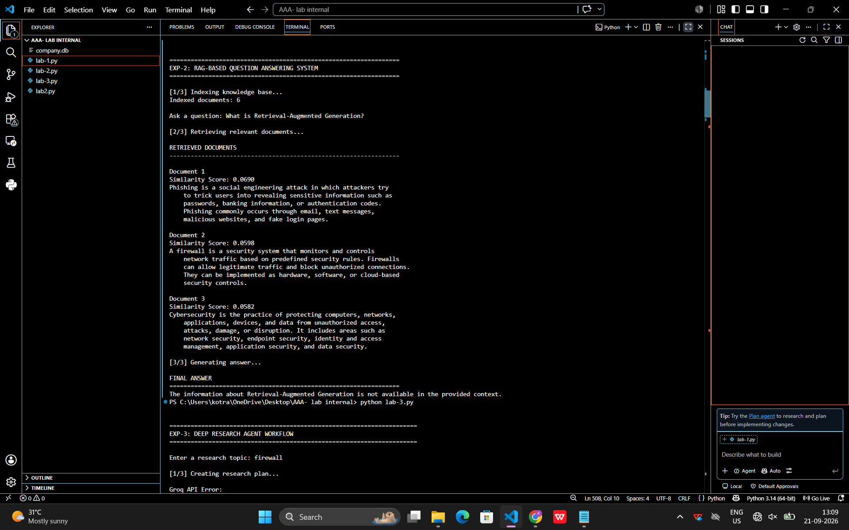

a# ============================================================
# EXP-2: RAG-BASED QUESTION ANSWERING SYSTEM
# Implement indexing, retrieval, and response generation
# ============================================================

import re
import math
from collections import Counter
from groq import Groq

# ============================================================
# 1. GROQ CONFIGURATION
# ============================================================

# Put your NEW Groq API key here
GROQ_API_KEY = "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"

MODEL = "openai/gpt-oss-120b"

client = Groq(api_key=GROQ_API_KEY)

# ============================================================
# 2. SAMPLE KNOWLEDGE BASE
# ============================================================

documents = [
"""
Cybersecurity is the practice of protecting computers, networks,
applications, devices, and data from unauthorized access,
attacks, damage, or disruption. It includes areas such as
network security, endpoint security, identity and access
management, application security, and data security.
""",

"""
A Security Operations Center, commonly called a SOC, monitors
an organization's security environment. SOC analysts investigate
security alerts, identify suspicious activity, analyze logs,
respond to incidents, and help prevent future attacks.
""",

"""
Phishing is a social engineering attack in which attackers try
to trick users into revealing sensitive information such as
passwords, banking information, or authentication codes.
Phishing commonly occurs through email, text messages,
malicious websites, and fake login pages.
""",

"""
Multi-factor authentication, or MFA, provides an additional
layer of security during login. Instead of relying only on a
password, MFA can require another factor such as an authenticator
application, security key, fingerprint, or one-time password.
""",

"""
A firewall is a security system that monitors and controls
network traffic based on predefined security rules. Firewalls
can allow legitimate traffic and block unauthorized connections.
They can be implemented as hardware, software, or cloud-based
security controls.
""",

"""
SIEM stands for Security Information and Event Management.
A SIEM platform collects and analyzes security logs from
different systems such as servers, endpoints, applications,
firewalls, and network devices. SIEM helps security teams
detect suspicious activities and investigate incidents.
"""
]

# ============================================================
# 3. TEXT PREPROCESSING
# ============================================================

def preprocess(text):

text = text.lower()

words = re.findall(r"\b[a-zA-Z0-9]+\b", text)

return words

# ============================================================
# 4. DOCUMENT INDEXING
# ============================================================

def create_index(documents):

index = []

for document in documents:

words = preprocess(document)

word_count = Counter(words)

index.append({
"text": document.strip(),
"words": word_count
})

return index

# ============================================================
# 5. COSINE SIMILARITY
# ============================================================

def cosine_similarity(query_words, document_words):

all_words = set(query_words.keys()) | set(document_words.keys())

if not all_words:
return 0

query_vector = []
document_vector = []

for word in all_words:

query_vector.append(query_words[word])

document_vector.append(document_words[word])

dot_product = sum(
q * d
for q, d in zip(query_vector, document_vector)
)

query_magnitude = math.sqrt(
sum(q * q for q in query_vector)
)

document_magnitude = math.sqrt(
sum(d * d for d in document_vector)
)

if query_magnitude == 0 or document_magnitude == 0:
return 0

return dot_product / (
query_magnitude * document_magnitude
)

# ============================================================
# 6. RETRIEVAL
# ============================================================

def retrieve_documents(query, index, top_k=3):

query_words = Counter(
preprocess(query)
)

results = []

for document in index:

score = cosine_similarity(
query_words,
document["words"]
)

results.append(
(score, document["text"])
)

results.sort(
key=lambda x: x[0],
reverse=True
)

return results[:top_k]

# ============================================================
# 7. GROQ RESPONSE GENERATION
# ============================================================

def generate_answer(question, retrieved_documents):

context = "\n\n".join(
document
for score, document in retrieved_documents
if score > 0
)

if not context:

return "I could not find relevant information in the knowledge base."

prompt = f"""
You are a helpful cybersecurity assistant.

Answer the user's question using ONLY the information
provided in the context.

CONTEXT:
{context}

USER QUESTION:
{question}

RULES:
1. Use only the provided context.
2. Do not invent information.
3. If the answer is not present in the context,
clearly say that the information is not available.
4. Give a simple and clear answer.
5. Do not mention the internal RAG process.
"""

try:

response = client.chat.completions.create(
model=MODEL,
messages=[
{
"role": "user",
"content": prompt
}
],
temperature=0.2
)

return response.choices[0].message.content.strip()

except Exception as e:

print("\nGroq API Error:")
print(e)

return None

# ============================================================
# 8. MAIN RAG WORKFLOW
# ============================================================

def rag_question_answering():

print("\n")
print("=" * 65)
print("EXP-2: RAG-BASED QUESTION ANSWERING SYSTEM")
print("=" * 65)

# --------------------------------------------------------
# STEP 1: INDEXING
# --------------------------------------------------------

print("\n[1/3] Indexing knowledge base...")

index = create_index(documents)

print(
"Indexed documents:",
len(index)
)

# --------------------------------------------------------
# USER QUESTION
# --------------------------------------------------------

question = input(
"\nAsk a question: "
).strip()

if not question:

print("\nQuestion cannot be empty.")

return

# --------------------------------------------------------
# STEP 2: RETRIEVAL
# --------------------------------------------------------

print("\n[2/3] Retrieving relevant documents...")

retrieved_documents = retrieve_documents(
question,
index,
top_k=3
)

print("\nRETRIEVED DOCUMENTS")
print("-" * 65)

for number, (score, document) in enumerate(
retrieved_documents,
start=1
):

print(
f"\nDocument {number}"
)

print(
f"Similarity Score: {score:.4f}"
)

print(document)

# --------------------------------------------------------
# STEP 3: RESPONSE GENERATION
# --------------------------------------------------------

print("\n[3/3] Generating answer...")

answer = generate_answer(
question,
retrieved_documents
)

if answer:

print("\nFINAL ANSWER")
print("=" * 65)

print(answer)

# ============================================================
# 9. PROGRAM START
# ============================================================

if __name__ == "__main__":

if (
not GROQ_API_KEY
or
GROQ_API_KEY == "PASTE_YOUR_GROQ_API_KEY_HERE"
):

print("\nERROR")
print("-" * 65)

print(
"Please add your NEW Groq API key "
"at the top of lab-2.py."
)

else:

rag_question_answering()
- Deep Research Agent Workflow
Implement planning + reflection for content generation
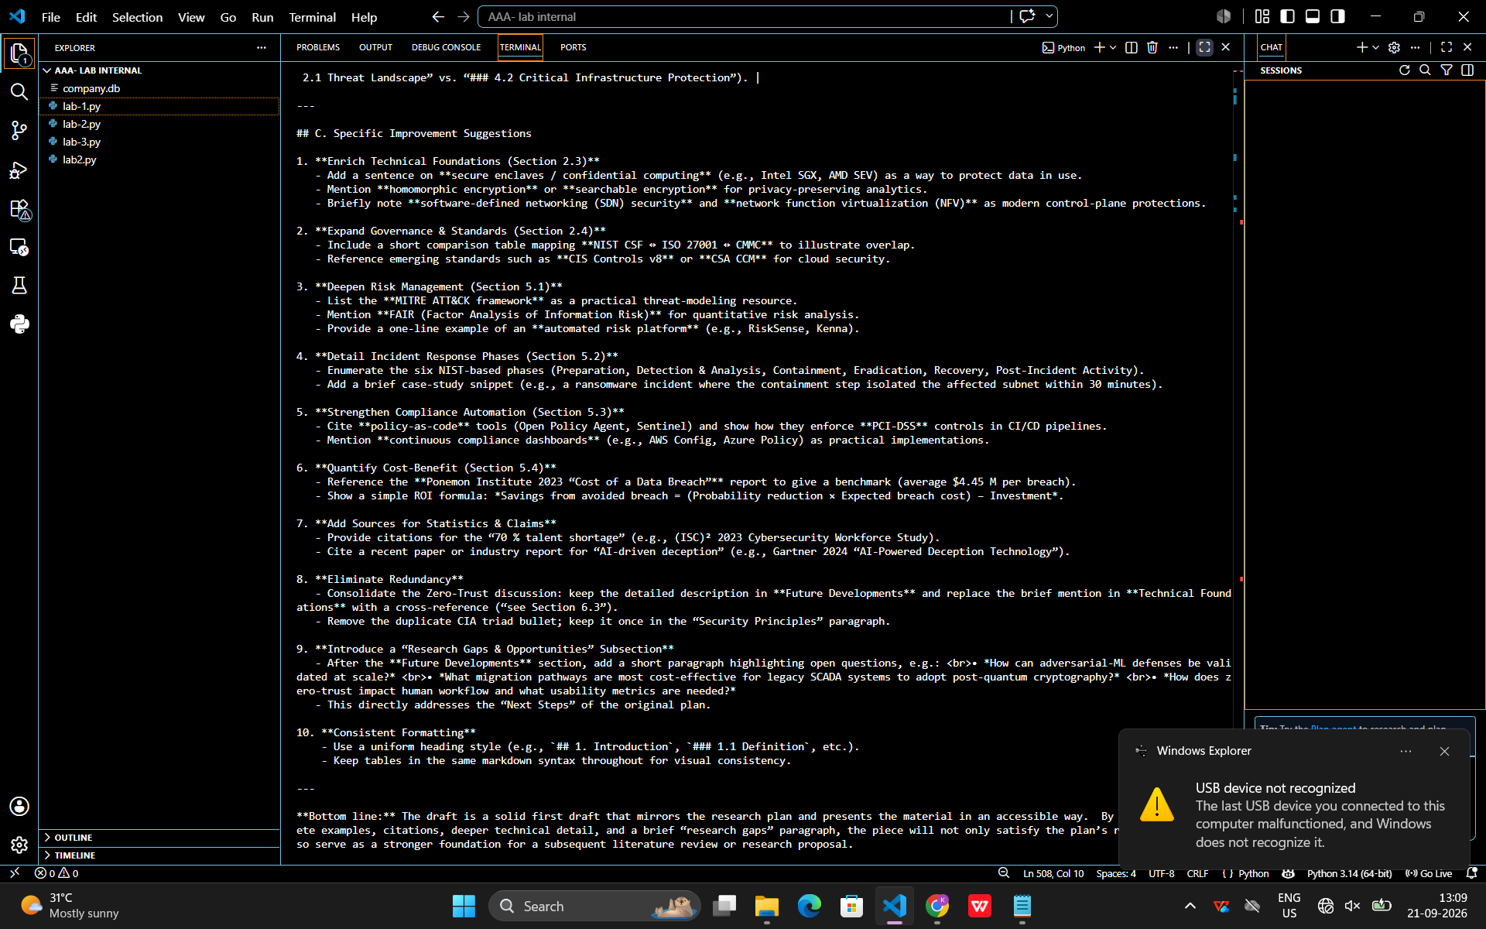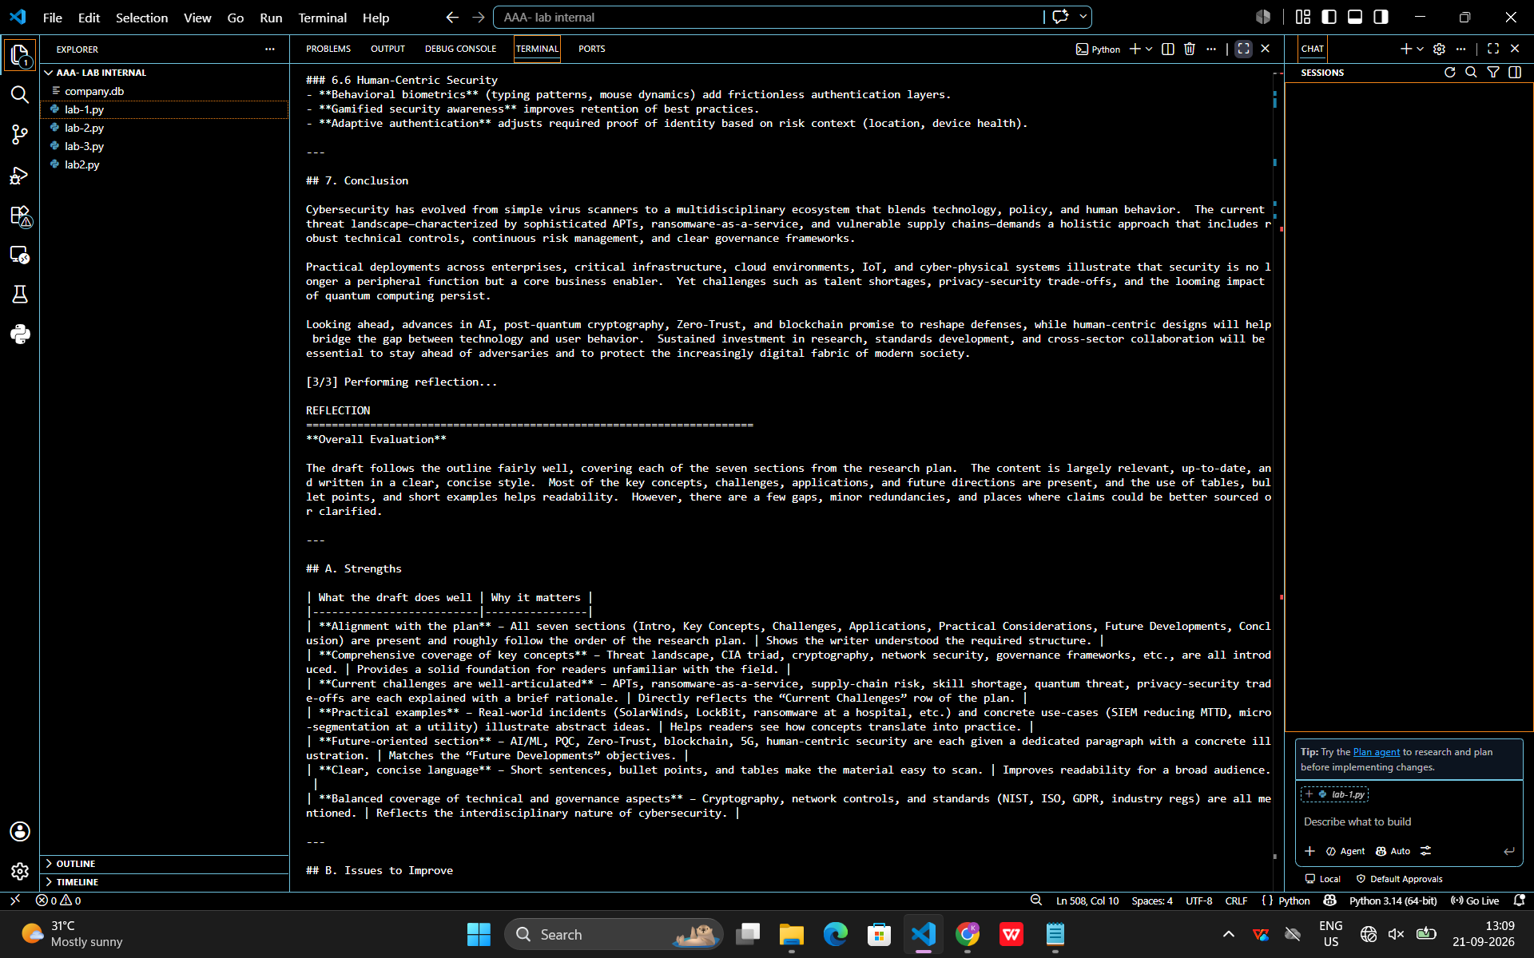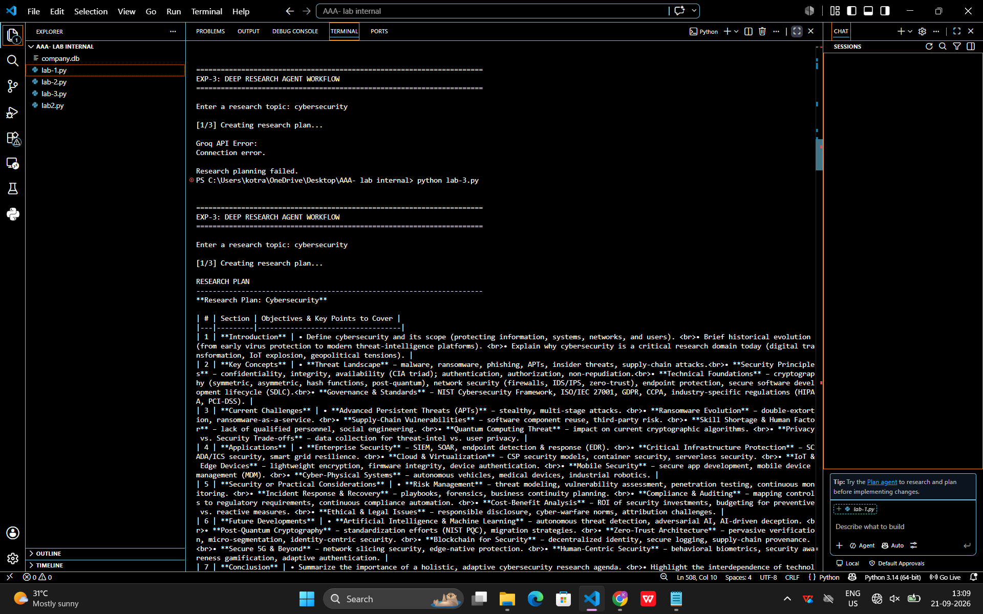

# ============================================================
# EXP-3: DEEP RESEARCH AGENT WORKFLOW
# Implement planning + reflection for content generation
# ============================================================

from groq import Groq

# ============================================================
# 1. GROQ CONFIGURATION
# ============================================================

# Put your NEW Groq API key here
GROQ_API_KEY = "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"

MODEL = "openai/gpt-oss-120b"

client = Groq(api_key=GROQ_API_KEY)

# ============================================================
# 2. GROQ FUNCTION
# ============================================================

def ask_groq(prompt, temperature=0.2):

try:

response = client.chat.completions.create(
model=MODEL,
messages=[
{
"role": "user",
"content": prompt
}
],
temperature=temperature,
timeout=60
)

return response.choices[0].message.content.strip()

except Exception as e:

print("\nGroq API Error:")
print("Error type:", type(e).__name__)
print("Error:", e)

return None

# ============================================================
# 3. PLANNING
# ============================================================

def create_research_plan(topic):

print("\n[1/3] Creating research plan...")

prompt = f"""
You are a research planning agent.

RESEARCH TOPIC:
{topic}

Create a clear research plan for studying this topic.

The plan should contain:

1. Introduction
2. Key concepts
3. Current challenges
4. Applications
5. Security or practical considerations
6. Future developments
7. Conclusion

Return a numbered research plan.

Do not write the full article yet.
Only create the research plan.
"""

return ask_groq(
prompt,
temperature=0.2
)

# ============================================================
# 4. CONTENT GENERATION
# ============================================================

def generate_content(topic, plan):

print("\n[2/3] Generating research content...")

prompt = f"""
You are a research content generation agent.

RESEARCH TOPIC:
{topic}

RESEARCH PLAN:
{plan}

Using the research plan, generate a clear and
well-structured research article.

Requirements:

1. Include a suitable title.
2. Follow the research plan.
3. Explain concepts in simple language.
4. Use clear headings.
5. Include practical examples where useful.
6. Avoid unsupported claims.
7. Do not repeat the same information.
8. End with a conclusion.

Generate the complete article.
"""

return ask_groq(
prompt,
temperature=0.3
)

# ============================================================
# 5. REFLECTION
# ============================================================

def reflect_on_content(topic, plan, content):

print("\n[3/3] Performing reflection...")

prompt = f"""
You are a reflection and quality-checking agent.

RESEARCH TOPIC:
{topic}

RESEARCH PLAN:
{plan}

GENERATED CONTENT:
{content}

Evaluate the generated content.

Check:

1. Does it follow the research plan?
2. Is the information relevant to the topic?
3. Is the structure clear?
4. Are important sections missing?
5. Is there unnecessary repetition?
6. Are there unsupported or unclear claims?
7. Is the explanation understandable?

Provide:

A. Strengths
B. Issues to improve
C. Specific improvement suggestions

Do not rewrite the complete article.
Only provide the reflection.
"""

return ask_groq(
prompt,
temperature=0.2
)

# ============================================================
# 6. IMPROVE CONTENT
# ============================================================

def improve_content(topic, plan, content, reflection):

print("\nGenerating final content based on reflection...")

prompt = f"""
You are a final content editor.

RESEARCH TOPIC:
{topic}

ORIGINAL CONTENT:
{content}

REFLECTION:
{reflection}

Improve the original content using the reflection.

Rules:
1. Keep the original topic.
2. Keep the important information.
3. Fix the issues identified in the reflection.
4. Remove unnecessary repetition.
5. Keep the language simple and professional.
6. Do not add unsupported facts.
7. Return only the improved article.
"""

return ask_groq(
prompt,
temperature=0.3
)

# ============================================================
# 7. MAIN DEEP RESEARCH WORKFLOW
# ============================================================

def deep_research_agent():

print("\n")
print("=" * 70)
print("EXP-3: DEEP RESEARCH AGENT WORKFLOW")
print("=" * 70)

topic = input(
"\nEnter a research topic: "
).strip()

if not topic:

print("\nTopic cannot be empty.")

return

# --------------------------------------------------------
# STEP 1: PLANNING
# --------------------------------------------------------

plan = create_research_plan(topic)

if not plan:

print("\nResearch planning failed.")

return

print("\nRESEARCH PLAN")
print("-" * 70)
print(plan)

# --------------------------------------------------------
# STEP 2: CONTENT GENERATION
# --------------------------------------------------------

content = generate_content(
topic,
plan
)

if not content:

print("\nContent generation failed.")

return

print("\nGENERATED CONTENT")
print("=" * 70)
print(content)

# --------------------------------------------------------
# STEP 3: REFLECTION
# --------------------------------------------------------

reflection = reflect_on_content(
topic,
plan,
content
)

if not reflection:

print("\nReflection failed.")

return

print("\nREFLECTION")
print("=" * 70)
print(reflection)

# --------------------------------------------------------
# STEP 4: IMPROVEMENT
# --------------------------------------------------------

improved_content = improve_content(
topic,
plan,
content,
reflection
)

if not improved_content:

print("\nContent improvement failed.")

return

print("\nFINAL IMPROVED CONTENT")
print("=" * 70)
print(improved_content)

# ============================================================
# 8. PROGRAM START
# ============================================================

if __name__ == "__main__":

if (
not GROQ_API_KEY
or
GROQ_API_KEY == "PASTE_YOUR_GROQ_API_KEY_HERE"
):

print("\nERROR")
print("-" * 70)
print(
"Please add your NEW Groq API key "
"at the top of lab-3.py."
)

else:

deep_research_agent()

